Dear Professor Sangermano,

I hope you are doing well. I am writing to express my interest in the Research Assistant/Intern position for July and August 2025. I am pursuing my M.S. in geographic information science at Clark University. I am writing to express my interest in the spatial database development and map publishing projects that you have mentioned in your advertisement.

My graduate coursework has equipped me with sound skills in geospatial analysis and programming. Some of the courses that I have completed include Advanced Remote Sensing, Advanced Vector GIS, Intermediate Quantitative Methods in Geography, Introduction to Geographic Information Science, Introduction to Remote Sensing, Computer Programming for GIS, and Python Programming (Figure 1). Through these courses, I have gained practical experience in managing spatial datasets, conducting advanced spatial analysis, and developing web-based maps using ArcGIS Pro and ArcGIS Online. To represent my mapping and research skills, I am providing some samples in the following-

|  |  |
| --- | --- |
| ArcGIS Pro | ArcGIS Online |
| * Classified LULC Map-2013 and 2023 (Figure 2) * LULC map of Worcester, MA (Figure 3) * Forest types and stream network map of insect infestation areas in Kennesaw national park, Georgia (Figure 4) * School districts dropout rate (2021-2022) of Massachusetts (Figure 5) * Spatial distribution of Cannabis business industry in Massachusetts (Figure 6) * Income based population distribution map of Worcester (Figure 7) * Forest loss hotspot analysis of Quabbin reservoir watershed forest (Figure 8) * Cluster and outlier analysis of forest gain in the Quabbin reservoir watershed forest (Figure 9) * Fire severity and infrastructure damage in Pacific Palisades (Figure 10) | * Northwestern districts Polygon of Bangladesh * Administrative Divisions of Bangladesh * Median Household Income in Worcester * Detecting Storm Risk Zones through Hotspot Analysis (2015–2021) * Northwest Districts Polygon of Bangladesh |

These works demonstrate my competence in gathering data from various sources, spatially organizing it, and publishing an interactive and informative web map. I am accountable, detail-oriented and dedicated to delivering quality outputs within the required time. I would appreciate the opportunity to work on your project and discuss it further at a convenient time.

For your concern, my current CV is attached herewith.

Thank you for considering my application.

Warm regards,

Sanjida Alam

M.S. Candidate, Geographic Information Science

Clark University

**Document and Maps**

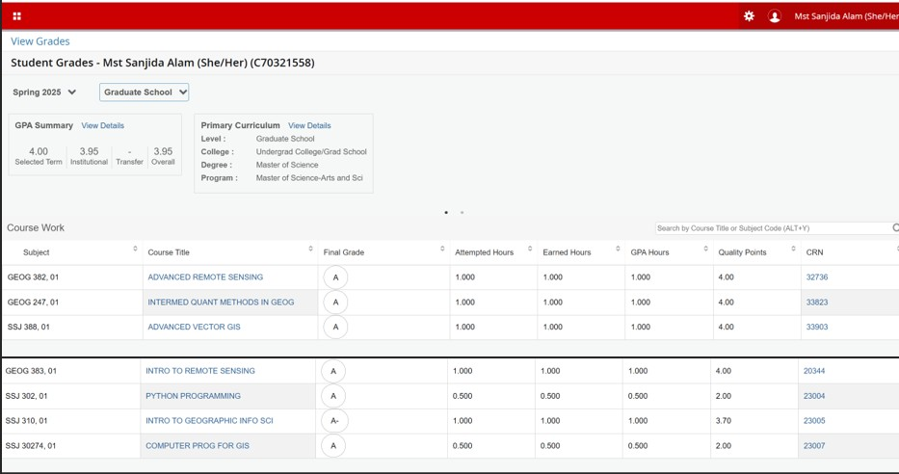

Figure 1: Courses completed in last two semesters

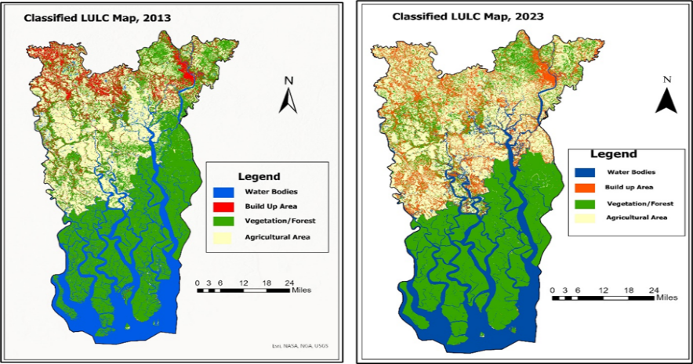

Figure 2: Classified LULC Map (2013 and 2023) of southern part of Khulna division Bangladesh



Figure 3: Temporal LULC Maps of Worcester City

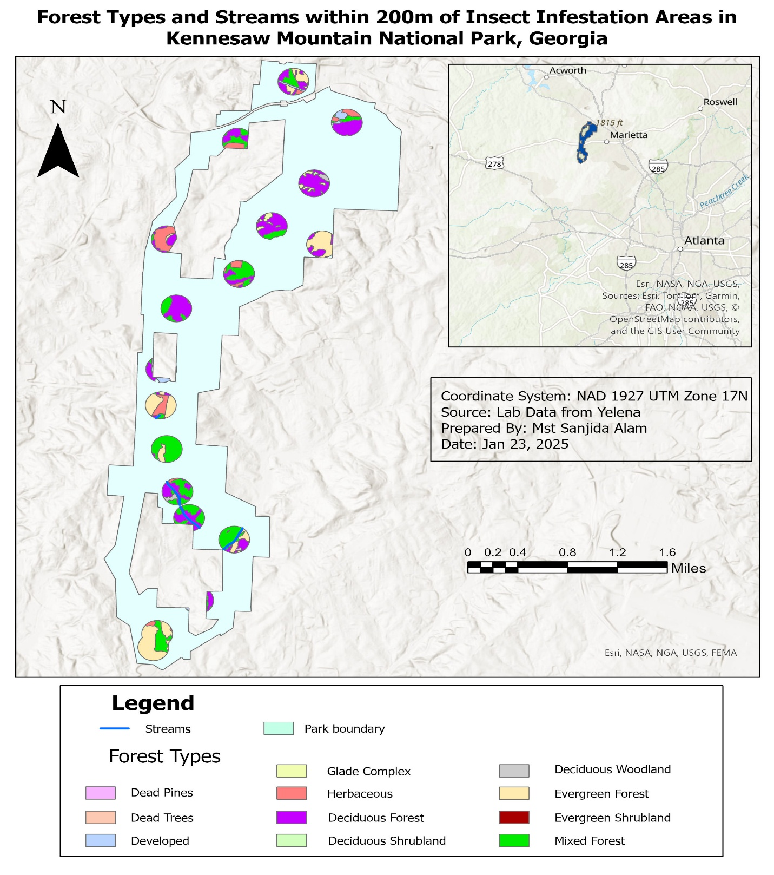

Figure 4: Forest types and streams near insect infestation areas in Kennesaw national park, Georgia

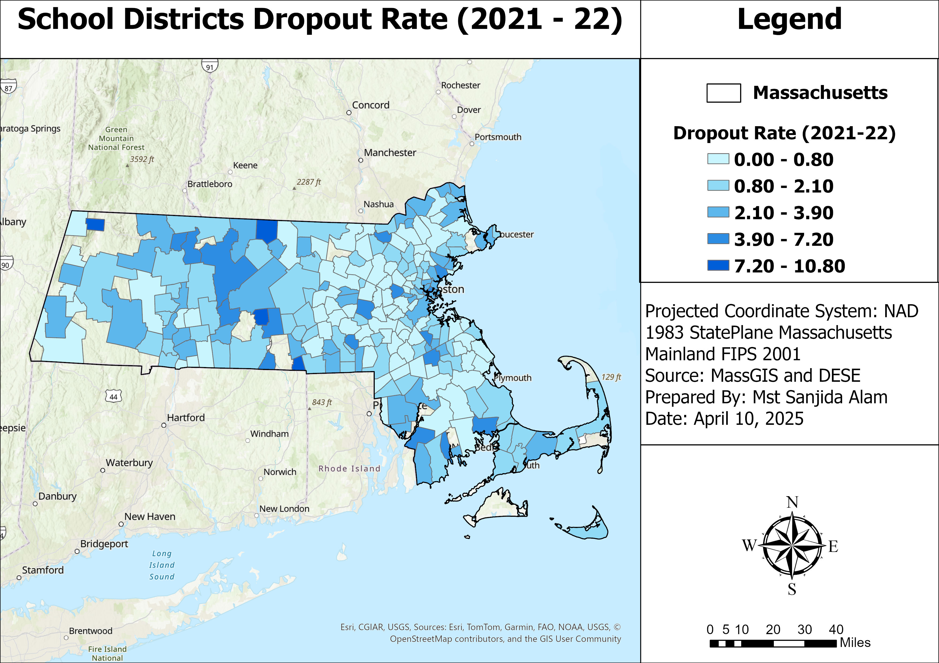

Figure 5: School districts dropout rate (2021-2022) of Massachusetts

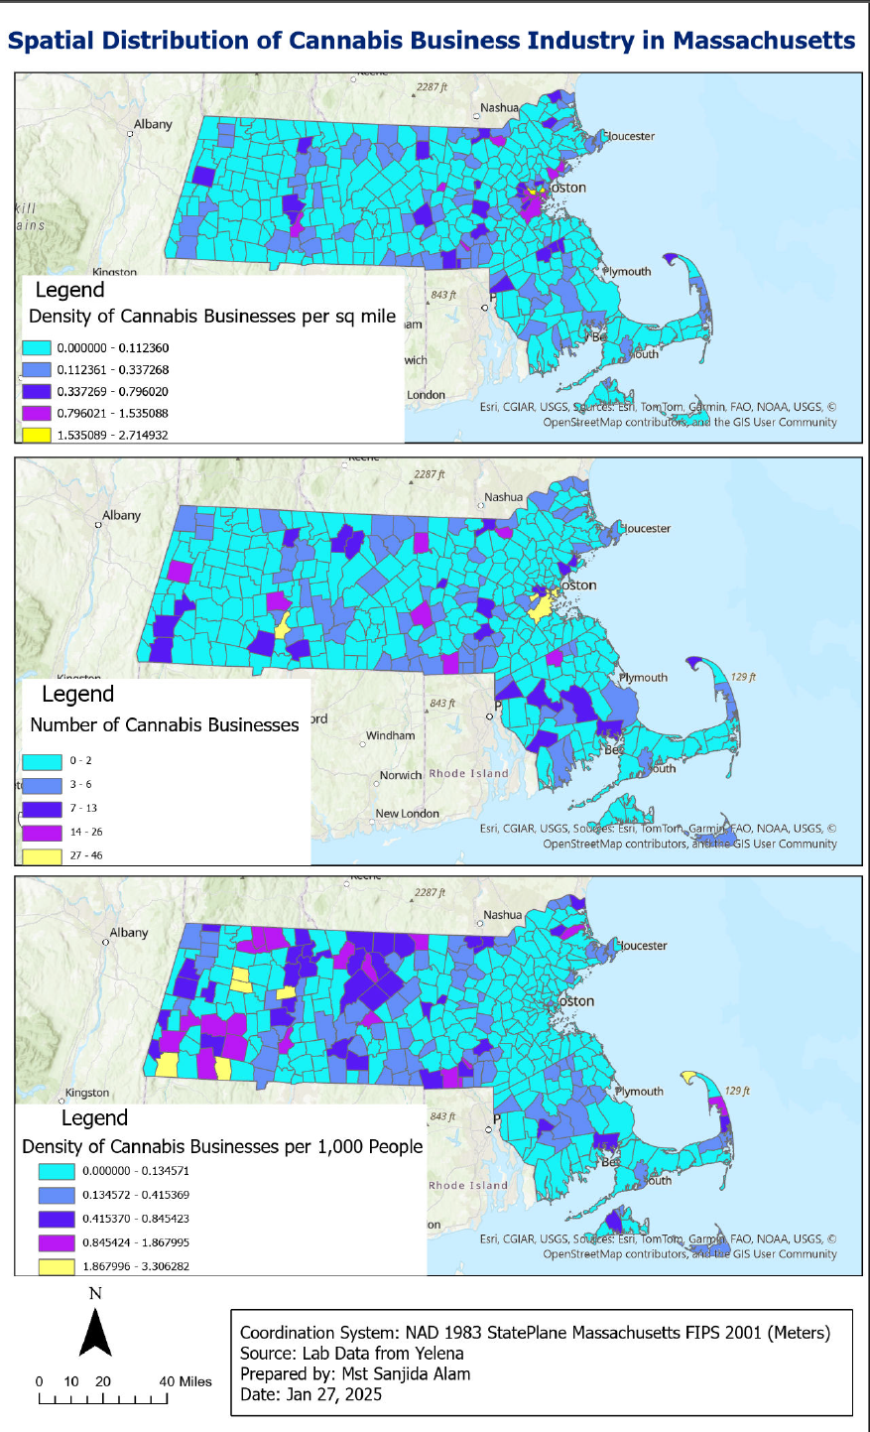

Figure 6: Spatial distribution of Cannabis business industry in Massachusetts

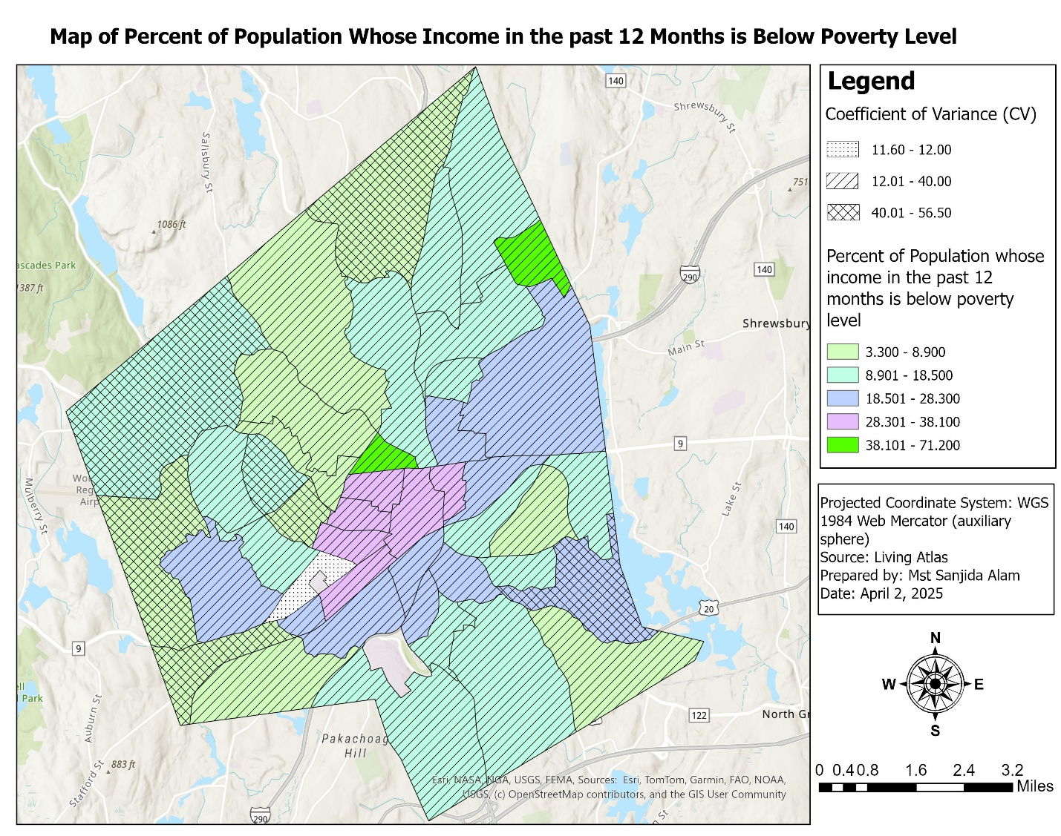

Figure 7: Income based population distribution of Worcester

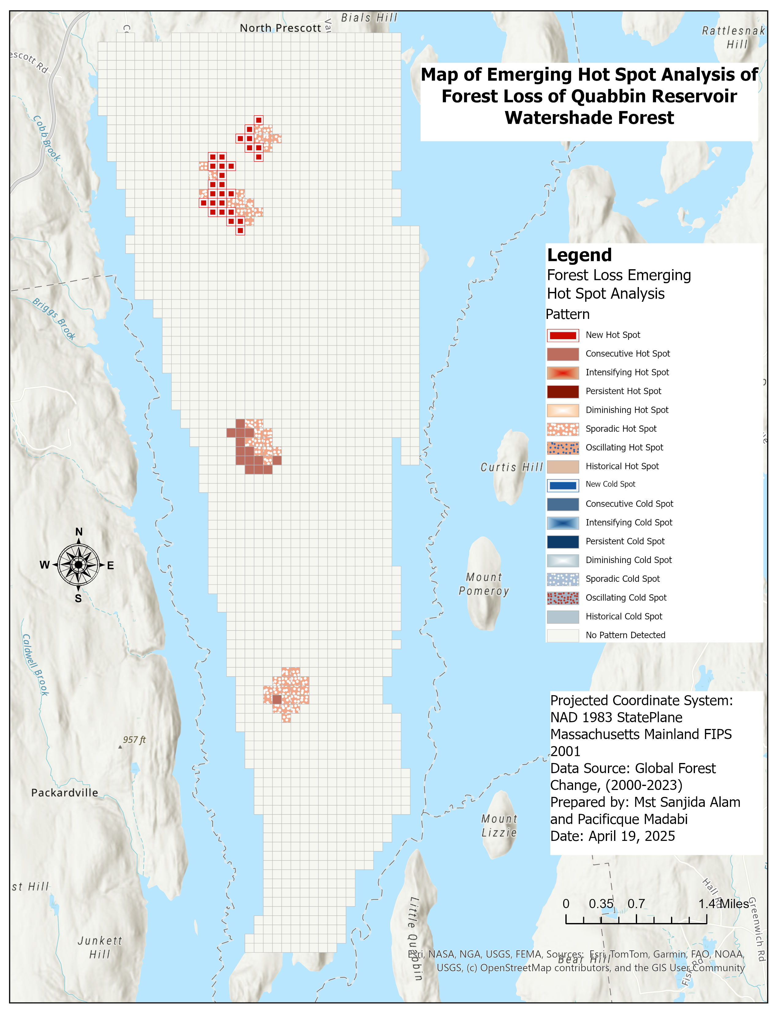

Figure 8: Forest loss hotspot analysis of Quabbin reservoir watershed forest

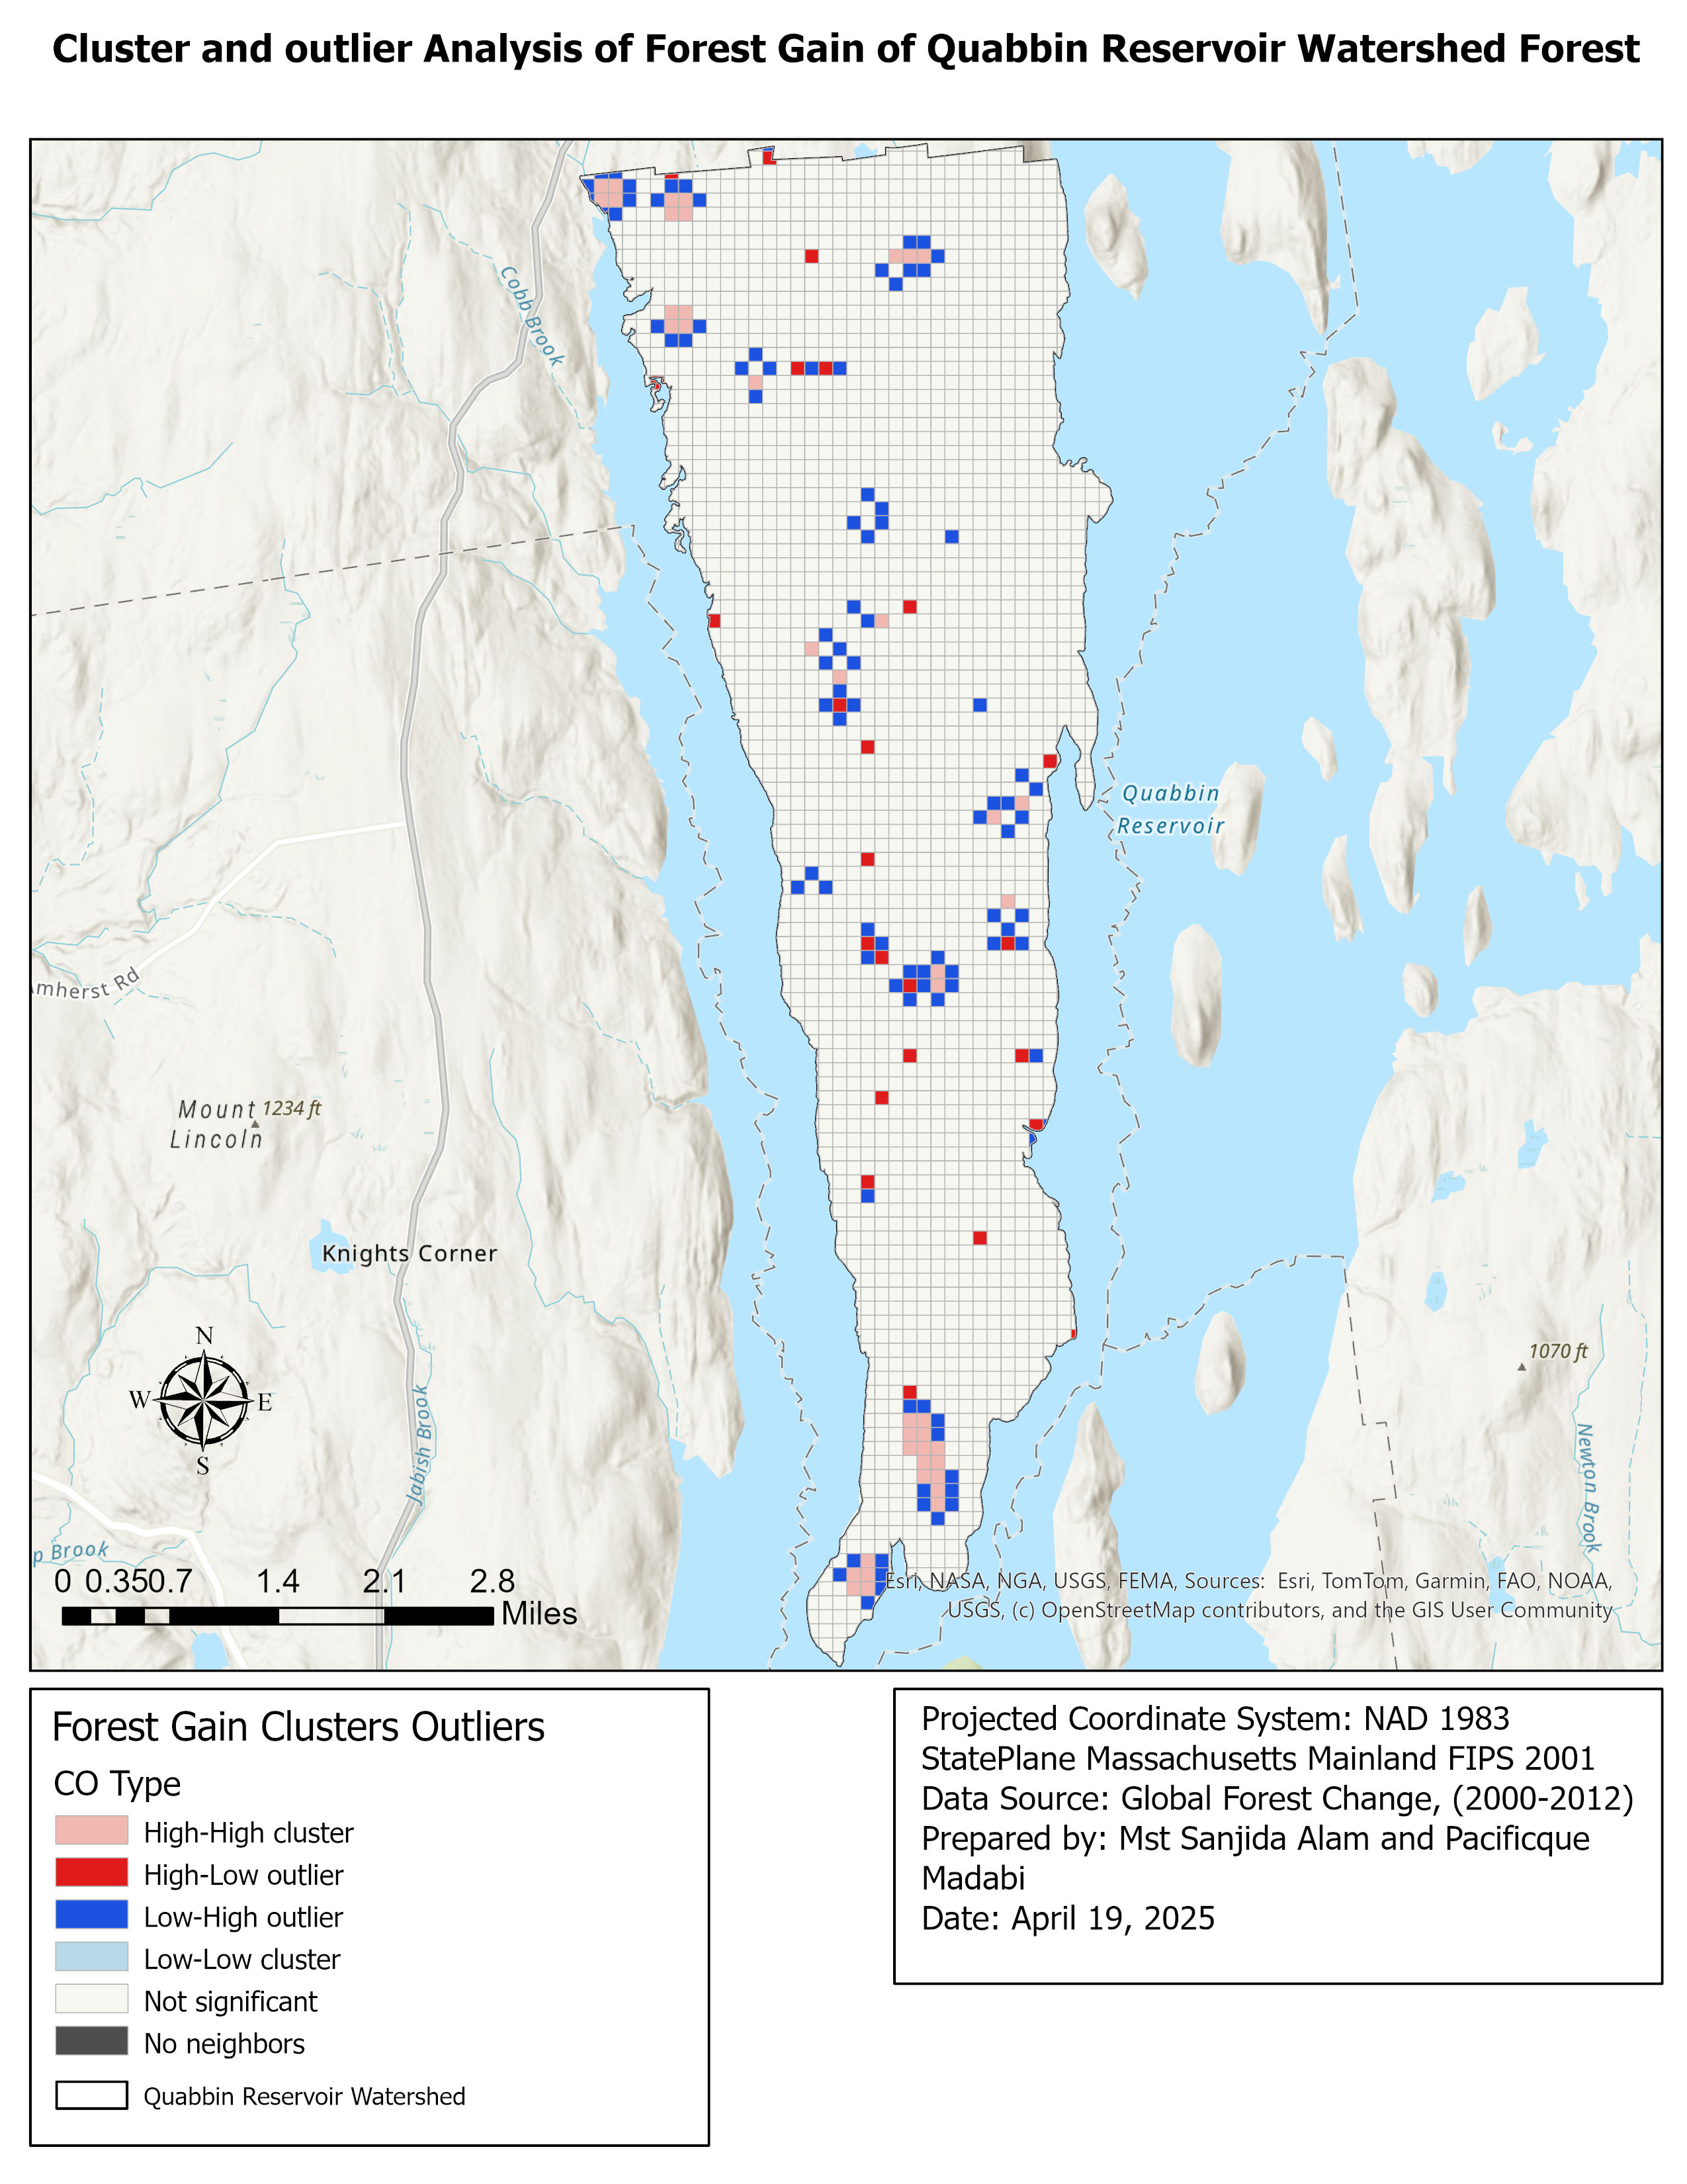

Figure 9: Cluster and outlier analysis of forest gain in the Quabbin reservoir watershed forest

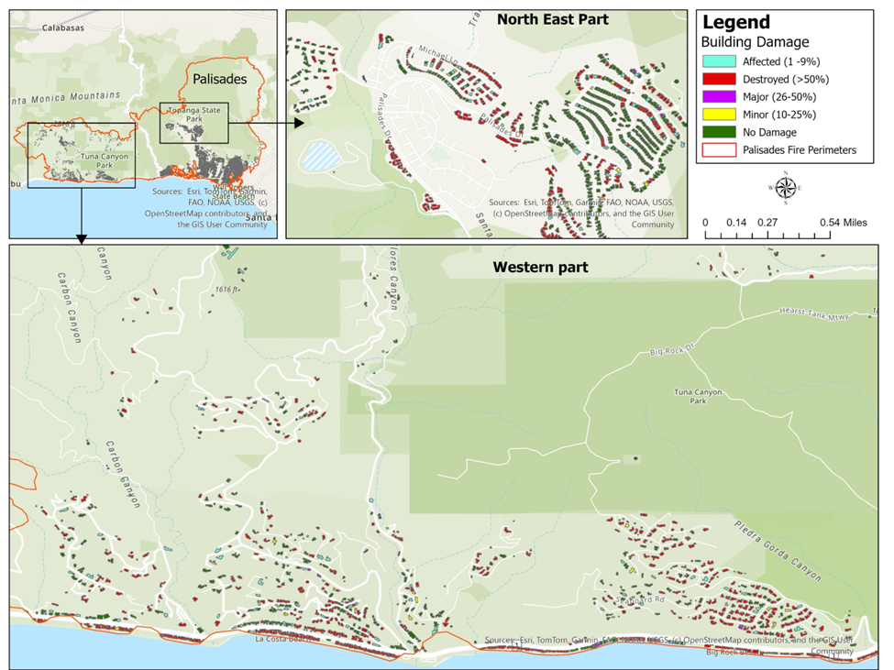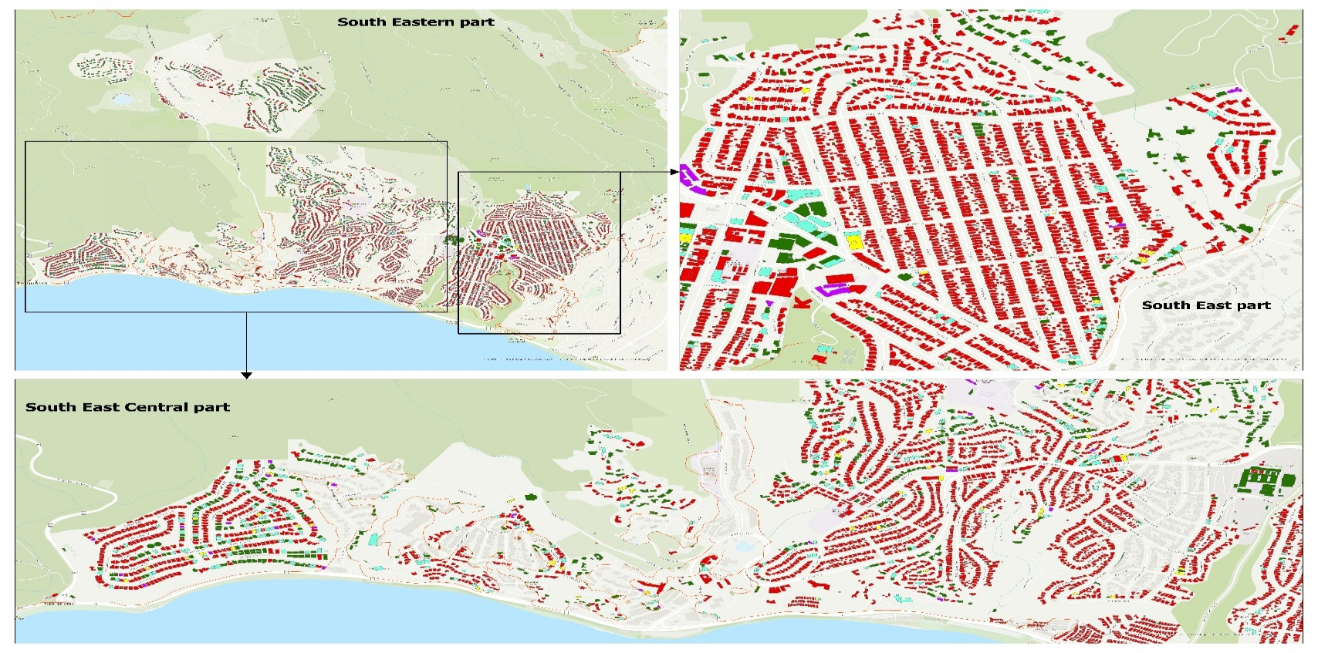

Figure 10: Fire severity and infrastructure damage in Pacific Palisades